Multimodal Retrieval-Augmented Generation (MRAG)

Goal of this Module
The goal is to demystify Multimodal RAG (MRAG), the advanced evolution of classic text RAG that handles queries and knowledge across text, images, tables, documents, video, and audio. You'll learn:
- Why MRAG is harder but more powerful than text RAG
- Core pipeline stages: query understanding → retrieval → reranking → context packing → grounded generation
- Three main retrieval paradigms (text-first, vision-first, joint) and their trade-offs
- Practical techniques for document/table handling, visual grounding, cross-modal reranking, and iterative/multi-hop retrieval
- How to avoid common pitfalls like hallucinations, modality bias, and context explosion This equips you to build production MRAG systems (e.g., TechVista support bot) that truly "see" customer photos, read spec sheets, and give accurate, cited answers.
Text RAG is simple: chunk text → embed → retrieve similar chunks → stuff into LLM prompt → generate.
MRAG introduces complexity at every stage because information lives in images, tables, videos, audio, and their combinations. Key differences:
- Input queries can be multimodal (text + photo of broken phone).
- Retrieval targets include non-text (raw images, doc regions, video frames + transcripts).
- Embeddings need cross-modal alignment (text "wireless ANC earbuds" should match product photos + spec tables).
- Context is richer but messier — images/tables can't be naively concatenated like text.
- Generation requires multimodal models (VLMs like GPT-4o, Gemini, LLaVA-Next) to reason over mixed inputs and output grounded text (sometimes with images/tables inline).
- Pitfalls multiply: visual hallucinations, modality bias (trusting text over image), poor cross-modal retrieval, context packing explosions.
Surveys emphasize: MRAG reduces hallucinations by grounding in visual evidence, but only if retrieval preserves semantics and generation stays faithful to retrieved multimodal content.

MRAG Core Components
Modern MRAG pipelines follow this flow
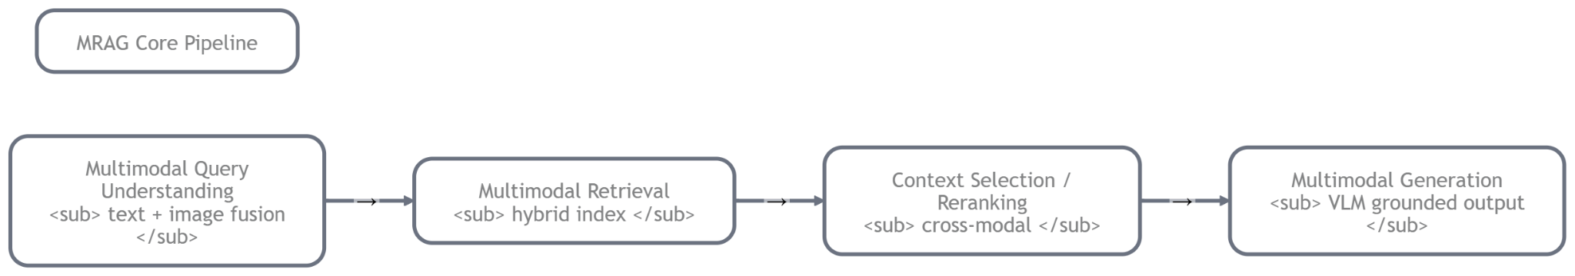

Multimodal Query Understanding
- The system first parses what the user actually wants — and in which modalities.
  - If query is pure text → standard embedding.
  - If query includes image (e.g., customer uploads cracked screen photo) → use VLM to summarize or extract intent ("user is showing damaged earbuds, likely warranty query").
  - Hybrid: fuse text + image embeddings for the query vector.
- Practical at TechVista: Customer types "This isn't working" + uploads photo → VLM understands "query about faulty wireless earbuds + visual evidence of defect" → creates a rich query embedding that searches both text specs and visual damage patterns.

Multimodal Retrieval
- The heart of MRAG — fetch relevant chunks from the corpus.
  - Use hybrid index (from Module 4): dense vectors (CLIP/SigLIP for images, ColPali for doc pages) + sparse (BM25 for text).
  - Retrieve across modalities: text chunks, image-text pairs, full doc regions (with layout), video clips + ASR transcripts.
  - Often multi-vector: one vector per modality, late fusion at retrieval time.
- Example: For "Compare ANC on Sony WH-1000XM5 vs Bose QuietComfort" → retrieve product photos, comparison tables from PDFs, unboxing video snippets, review audio clips.

Context Selection / Reranking
- Raw retrieval often returns noise — rerank to pick the most useful pieces.
  - Use cross-modal reranker (e.g., fine-tuned ColBERT-style or VLM-based scorer).
  - Filter by metadata (reliability ≥ 8, recent timestamps).
  - Diversity reranking to avoid redundant images.
  - Limit to top-5–10 to fit context window.
- At TechVista: Initial retrieval might grab 20 items → reranker scores them on relevance to the damage photo + query → keeps the clearest crack images + accurate spec tables.

Multimodal Generation (Grounded Responses)
- Feed selected multimodal context to a VLM → generate answer that cites visuals.
  - Prompt engineering: "Use the provided images/tables only — describe exactly what you see."
  - Output format: text explanation + inline references ("As shown in Image 2, the crack is on the right side...").
  - Advanced: agentic loop (if unclear, retrieve more or ask clarifying question).
- Result for TechVista customer: "Your earbuds show physical damage on the charging port (see retrieved photo). Warranty covers manufacturing defects but not accidental damage — check policy page 3 table."

Retrieval Targets: What You Actually Fetch
Surveys classify targets by granularity and modality:
- Text only → fast fallback, but loses visual nuance (e.g., misses chart colors).
- Image-text pairs → CLIP-style (product photo + caption/description) — great for visual search.
- Document regions → page/figure/table bounding boxes (ColPali embeds layout-aware) — ideal for manuals/spec sheets.
- Video clips + transcripts → keyframes + ASR text — for unboxing/review videos (e.g., "Show me how to pair these headphones").
TechVista example: Query "Why does my smartwatch screen scratch easily?" → retrieve product close-up photos, durability test video clip (with subtitles), scratched-unit customer images, spec sheet region on "Gorilla Glass".

Context Packing: How to Format Mixed Content Without Losing Grounding
This is a huge practical pain point — VLMs have token limits, and naive packing destroys meaning.
Common strategies from recent works:
- Image placeholders + descriptions Prompt: "Image 1: [description from caption or short VLM summary]. Image 2: ..." Then reference "Look at Image 1's crack pattern".
- Multimodal prompt templates Use special tokens like <image> or base64-encoded images (if model supports). Order matters: put most relevant images first.
- For tables Convert to markdown + embed image of table → "Table 1 (image attached): Battery life comparison..."
- Compression tricks Summarize long videos to key frames + highlights. Use token-efficient packing (group related chunks).
- Grounding enforcement Add instructions: "Only use information visible in the retrieved images/tables. If uncertain, say so." Post-generation check: verify claims against retrieved regions.
Pitfall example: Packing 10 images without order → model ignores half.
Solution: Reranker sorts by relevance score + diversity → pack top 4–6 with clear labels.
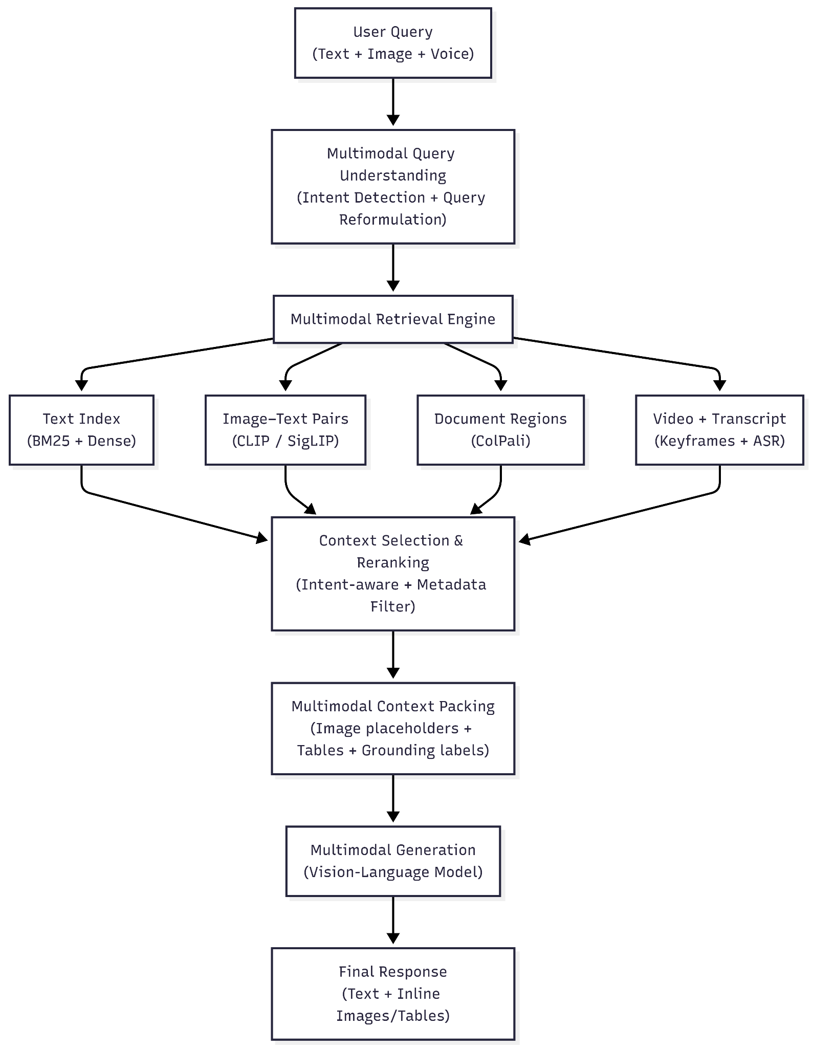

Retrieval in MRAG: Three Main Paradigm
Retrieval in MRAG isn't just “find similar stuff.” Because information lives in different forms (text descriptions, product photos, comparison tables, blurry customer-uploaded defect images, 30-second unboxing clips), you need different ways to hunt for relevance. The field has converged on three main paradigms

Text-first Retrieval (OCR / Captions → Retrieve)
Convert everything possible to text first, then use a powerful text retriever (BM25, dense text embeddings like e5-large, or even late-stage LLM reranking). Visual information is “squeezed” into words before retrieval happens.

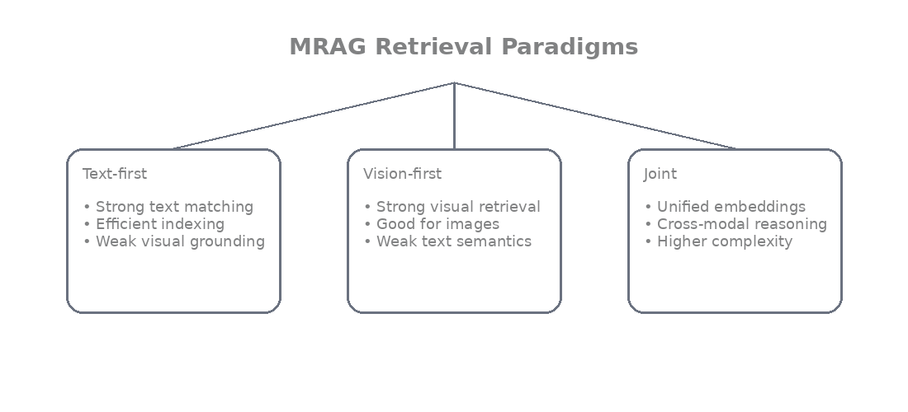
How it works in depth:
- For born-digital PDFs (clean manuals from Sony/Bose): extract text directly with PyMuPDF or pdfplumber.
- For scanned PDFs or product images: run heavy-duty OCR (TrOCR, Donut, Nougat, or layout-aware models like LayoutLMv3) → get raw text + sometimes layout hints.
- For tables: convert to markdown/CSV via Table Transformer or deepdoctection → flatten into text like “Model | Battery Life | ANC Level\nWH-1000XM5 | 30h | Yes”.
- For images/videos: generate captions (BLIP-2, LLaVA captioning, or even short VLM summaries like “close-up of cracked phone screen near charging port”) and store those captions + OCR-extracted text.
- Then embed the text (or chunks) with a text encoder → retrieve with cosine similarity or hybrid sparse+dense.
Advantages (why companies still love it in production):
- Text retrievers are mature, fast, cheap (BM25 is lightning), and interpretable.
- You can do keyword filtering (“ANC” + “Sony”) very reliably.
- Works even when vision models are expensive or slow.
Big downsides (the reason it's no longer the only game):
- Massive information loss: layout, colors, spatial relationships, fine visual details vanish.
- OCR errors compound (misread serial number → wrong warranty policy retrieved).
- Captioning is lossy: a blurry damage photo might get captioned “damaged device” → useless for distinguishing crack vs scratch vs dent.
Customer uploads photo of earbuds case with visible crack + types “Is this covered?”.
Text-first system: OCR/caption → “wireless earbuds case with damage” → retrieves generic warranty text saying “physical damage not covered” → answer is correct but vague (doesn't point to exact photo evidence).
Result: Customer feels “the AI didn't really look at my picture.”

Vision-first Retrieval
Treat the visual modality as primary. Embed raw images/pages/frames directly with a vision or vision-language model → retrieve based on visual similarity, ignoring or minimally using text.
How it works in depth:
- Use models like CLIP, SigLIP, ImageBind, or newer ones like ColPali (which embeds document pages as images without OCR).
- For documents: render PDF page as high-res image → feed to ColPali/PaliGemma → get multi-vector embeddings per patch/token.
- For product photos/customer uploads: direct CLIP embedding of the raw JPEG.
- For video: extract keyframes every 2–5s → embed each → aggregate or retrieve top keyframes.
- Retrieval is pure cosine similarity in vision embedding space.
Advantages:
- Preserves visual nuance perfectly — color gradients, texture of crack, layout of table columns.
- No OCR errors — ColPali famously beats OCR-based methods on document retrieval benchmarks because it “sees” the page like a human.
- Great for visual similarity search (e.g., “find products that look like this damaged one”).
Downsides:
- Text semantics can be weak — “ANC” keyword won't match unless visually associated.
- Compute-heavy at scale (embedding every PDF page as image is expensive).
- Hard to do keyword filtering or exact match.
Query: “Show me phones with similar scratch pattern to this uploaded photo.”
Vision-first: embed uploaded scratch photo with CLIP → retrieve visually similar product damage images from catalog + customer returns → perfect matches even if captions are generic.

Joint Retrieval
Don't choose one modality, use both (or all) in a coordinated way
Paired / Aligned Embeddings — Pre-align text and image in shared space (CLIP-style) so “ANC earbuds” text embedding is close to photos of earbuds with ANC icon. Retrieve with joint similarity (weighted sum or late fusion: s = λ·s_text + (1-λ)·s_image).
Cross-Encoders / Cross-Modal Rerankers — First-stage bi-encoder retrieval (fast, cheap) gets top-100 candidates → second-stage cross-encoder (slow, accurate) scores query+document pair jointly (takes image patches + text tokens together). Models like MM-R5 or multimodal ColBERT do this.
Answer-aware Reranking — Use the candidate context to generate a provisional answer → rerank based on how well the candidate supports that provisional answer (self-consistency or answer-relevance scoring).
Why it's powerful:
- Combines speed of first-stage + precision of second-stage.
- Handles modality imbalance (trust image more when text is noisy).
- “Answer-aware” variant dramatically reduces hallucinations — if provisional answer says “crack on left side” but candidate image shows right side, downrank it.

Complex query: “Compare battery drain causes from manual table + this photo of my usage screen.”
Joint: First retrieve with hybrid (text keywords “battery drain” + image embedding of usage screenshot) → top-50 candidates → cross-modal reranker (VLM scores how well each supports comparison) → pack top-8 → generate grounded answer with citations like “As shown in retrieved Table 1 (page 4) and your screenshot (Image 2) …”.

Reranking for MRAG
Reranking is almost mandatory in MRAG because first-stage retrieval (bi-encoders) is recall-oriented but low precision.

Cross-modal reranker:
- Input: query (text + optional image) + candidate (image/text/table/video snippet).
- Output: relevance score (0–1).
- Models: fine-tuned FLMR, MM-R5 (reasoning-enhanced), or even LLaVA-Next as zero-shot reranker (“Rate how relevant this image/table is to the question on a scale 1–10”).

Answer-aware reranking:
- Generate quick provisional answer from top-k raw retrieval.
- Rerank candidates by how much they support/corroborate that provisional answer (e.g., entailment score or VLM reasoning trace).
- Reduces modality bias (e.g., over-trusting noisy OCR text).

Iterative Retrieval (Multi-hop MRAG)

For complex questions (“Why does this smartwatch overheat during GPS? Check manual + reviews + similar user photos.”), single-shot retrieval fails.
How iterative / multi-hop works:
- Start with initial query → retrieve round 1 → VLM reasons (“Need GPS specs from manual + overheating images from reviews”) → rewrite query multimodally (text rewrite + generated image query embedding) → retrieve round 2 → repeat 2–4 times.
- “Retrieve → reason → retrieve again” loop (agentic style).
- Query rewriting can be cross-modal: VLM generates “search for smartwatch with red overheating warning icon” from initial text.
Initial query: “Is this laptop hinge issue common?” + photo.
Round 1: Retrieve similar hinge damage photos.
VLM reasons: “Need to check build quality in manual + user reviews.”
Rewritten queries: text “laptop hinge durability” + image embedding of hinge area.
Round 2: Retrieve manual page region + review snippets → final grounded answer.

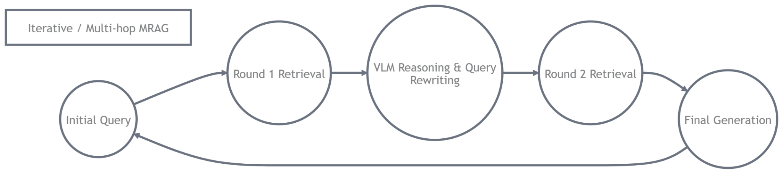

Document & Table MRAG

PDFs
Born-digital (vector PDFs from manufacturer): text is extractable, layout preserved → use LayoutLMv3 or ColPali (image-based but layout-aware).
Scanned (customer invoices, old manuals): noisy OCR → ColPali shines because it embeds the rendered page image directly (no OCR needed) → much higher recall on tables/figures.
Layout sensitivity: ignore layout → table rows get scrambled. Preserve it → ColPali or DocLayout-YOLO keeps spatial meaning.

Table Handling
- Table as text (classic): extract markdown → embed text → loses alignment/colors.
- Table as image (vision-first): render table region → embed with ColPali → preserves visual structure.
- Structure graph / dual-mode decomposition (state-of-the-art): parse table into graph (rows/columns/cells as nodes, relations as edges) + embed both text version and image version → retrieve jointly. Dual-mode = text path + vision path fused.

Visual Grounding in Documents
- Page-region retrieval: ColPali retrieves whole pages but scores per patch → highlight relevant region (bounding box) in answer.
- Cite snippets: Answer says “See Table 3, row 2, column ‘Battery Life’ on page 8 of retrieved PDF.”
- Traceability: Metadata + lineage (from earlier module) lets user click “why this page?” → shows retrieval score + region heat-map.

Query: “What’s the IP rating difference between these two earbuds models?” + photo of packaging.
System: ColPali retrieves spec-sheet pages → dual-mode table decomposition pulls exact rows → visual grounding highlights IP68 vs IPX4 cells → answer “Model A has IP68 (dust & water resistant) vs Model B’s IPX4 (splash only) — see highlighted region in retrieved page image.”

Context Packing: Formatting Mixed Content
- Image placeholders + descriptions ("Image 1: cracked charging port").
- Multimodal tokens (<image>, base64 if supported).
- Tables → markdown + image.
- Compression: key frames + highlights.
- Grounding: "Only use visible info"; post-check claims.
Pitfall: Unordered 10 images → ignored. Solution: Relevance-sorted + labeled top 4–6.

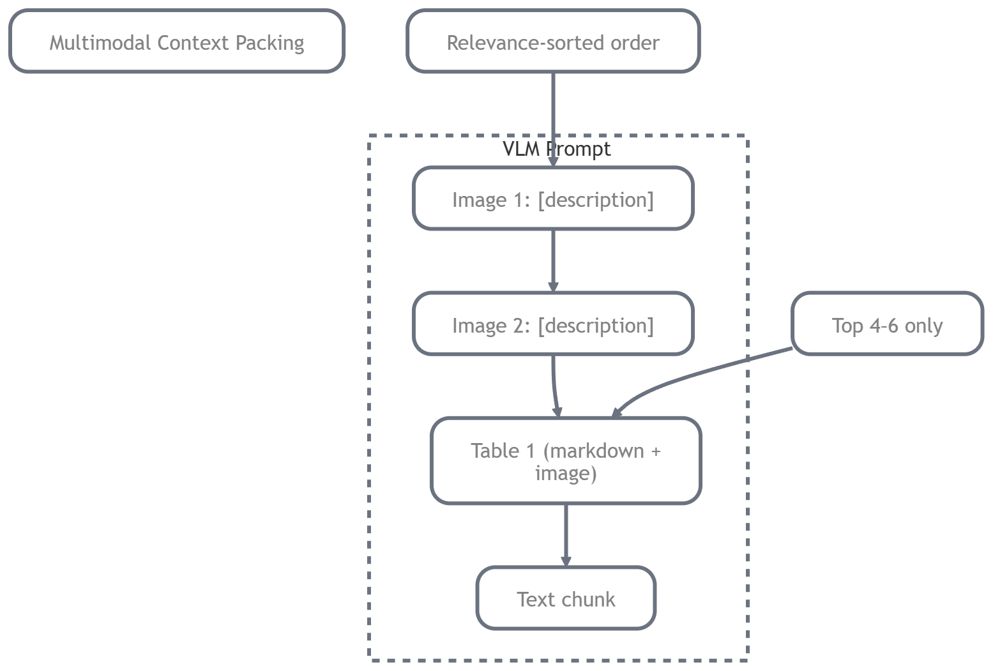

Conclusion & Key Takeaways
MRAG powers truly visual, grounded support, answering "Is this crack covered?" by seeing the photo, reading the policy, and citing both.

Key Takeaways
- MRAG pipeline: Multimodal query → hybrid/joint retrieval → cross-modal rerank → careful packing → VLM generation with grounding.
- Paradigms: Text-first (fast but lossy), vision-first (nuance but weak semantics), joint (best balance).
- Reranking & iterative retrieval fix precision/hallucinations; ColPali excels on docs/tables.
- Grounding + citations (regions, images) build trust — critical for e-commerce returns/warranty.
- In TechVista: Customer uploads defect photo → system sees it, retrieves policy regions/videos, generates cited, accurate response → fewer disputes, happier users.
Master MRAG and your system doesn't just read — it sees, understands, and explains what it sees reliably

